Object Oriented

Analysis and Design

Project Report

Deirdre Connolly

Bartosz Walusiak

CS2

# Table of Contents

**Table of Contents** **1**

**Assumptions Made** **2**

**Domain Model** **2**

**Use Case Diagram** **3**

**Wireframes** **4**

**Sequence Diagrams** **12**

**Design Class Diagram** **16**

**Design Class Mapping to Java** **17**

**Design Class Diagram Code** **18**

**Student Declaration** **19**

# Assumptions Made

While completing the design, we made the assumption that only the Office Administration staff can access this system. This means, for example, that a person who would like to enroll as a student of Hope Music Academy must register through the Office as they cannot do so themselves via an online system.

# Domain Model

Bart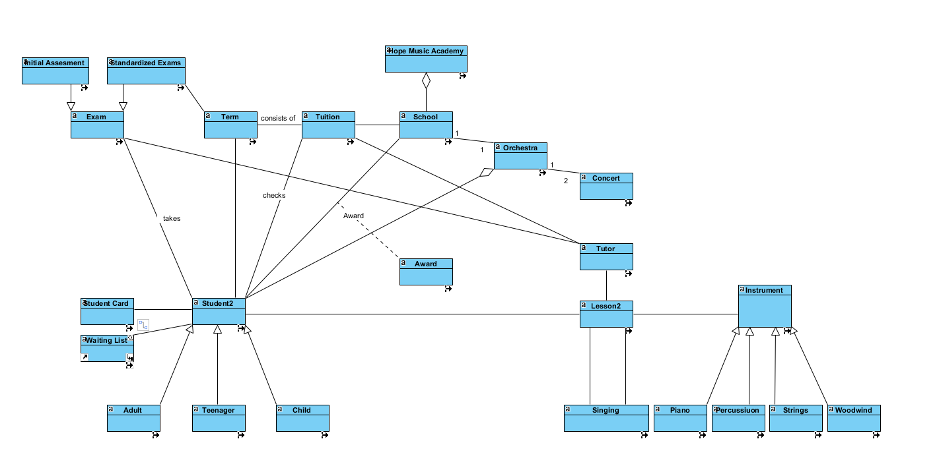

# Use Case Diagram

Deirdre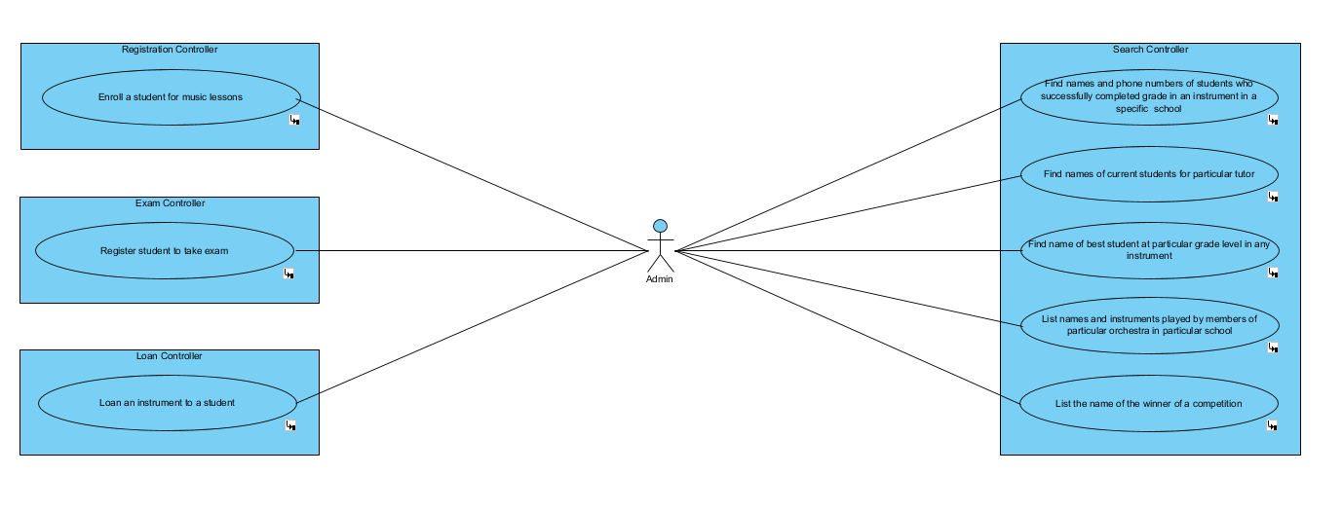

# Wireframes

(i) Deirdre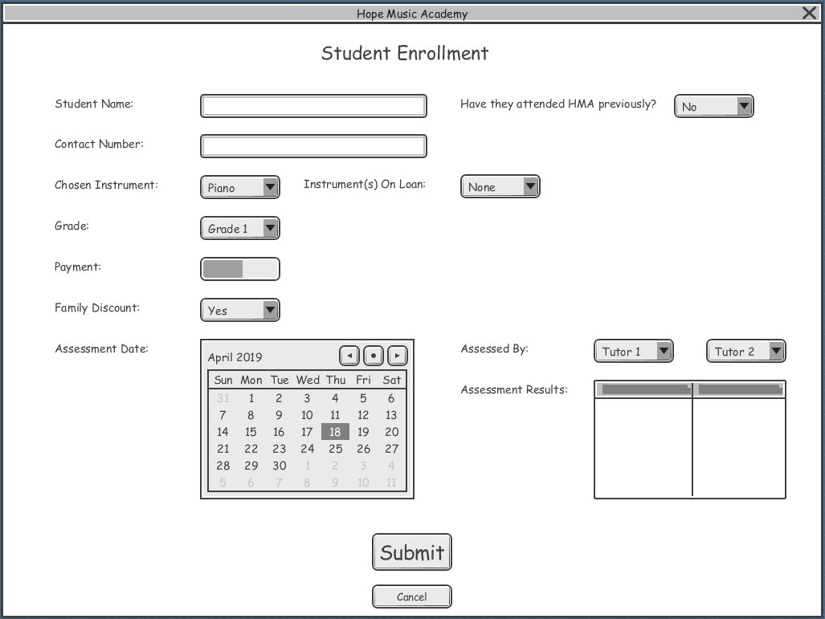

(ii) Bart

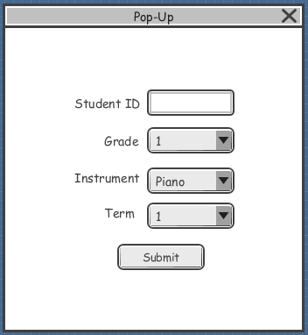

(iii) Deirdre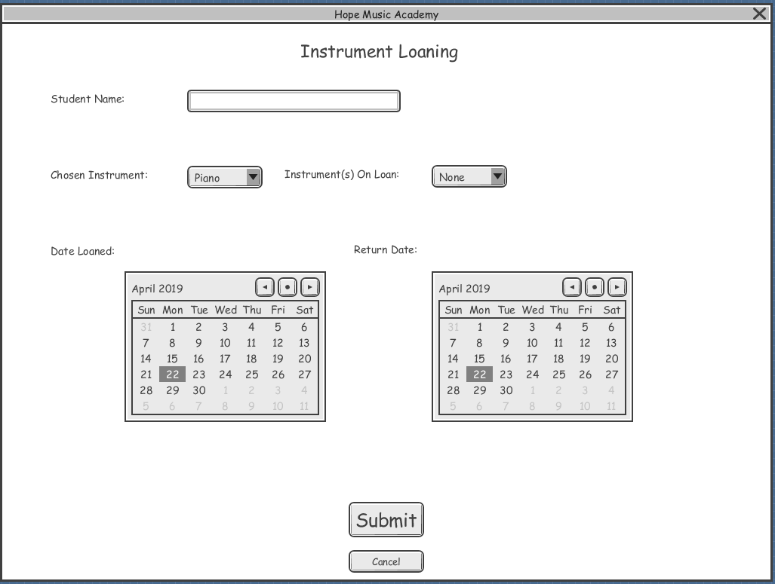

(iv) Bart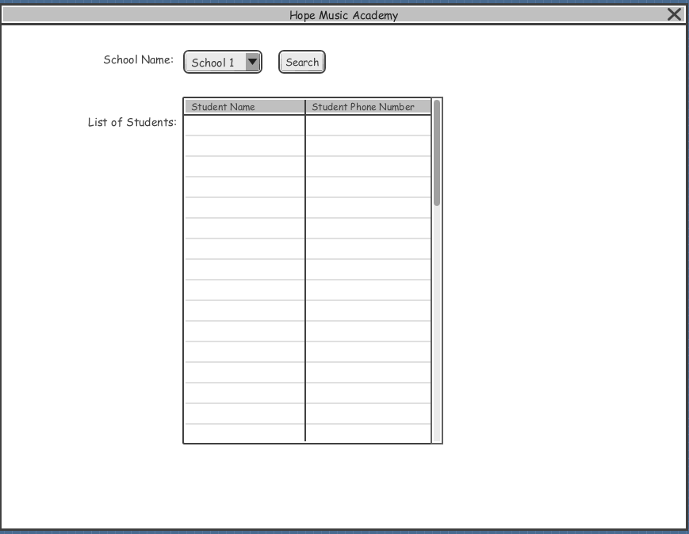

(v) Deirdre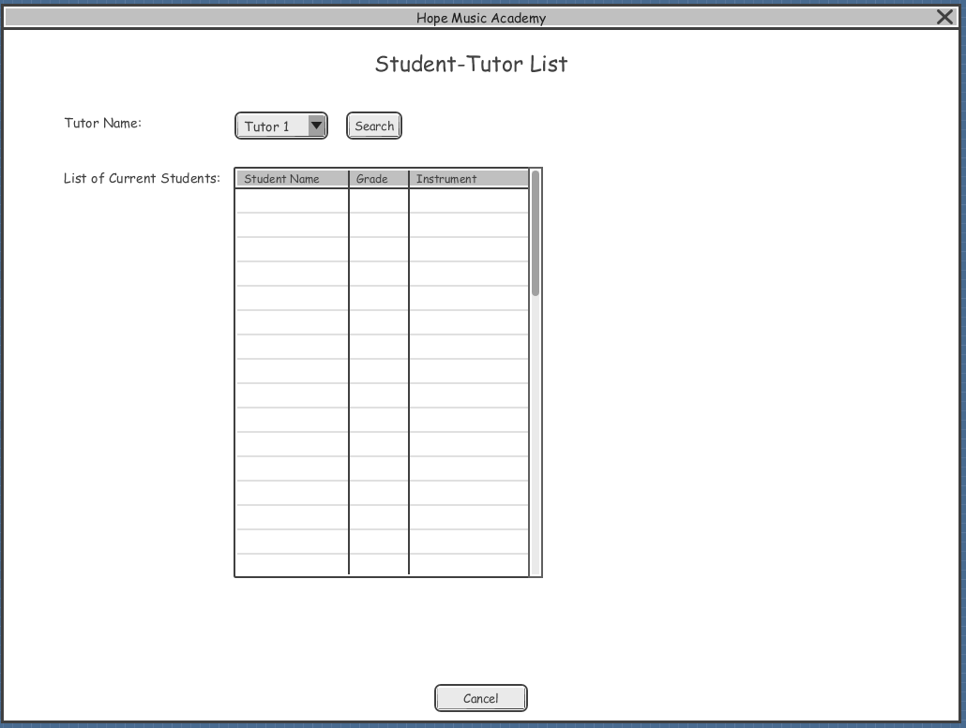

(vi) Bart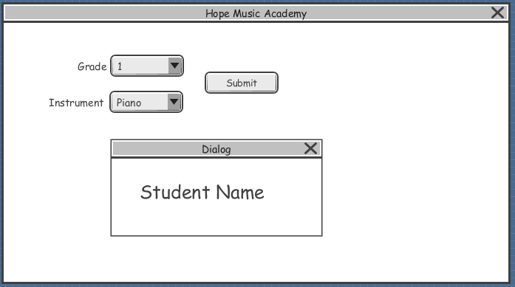

(vii) Deirdre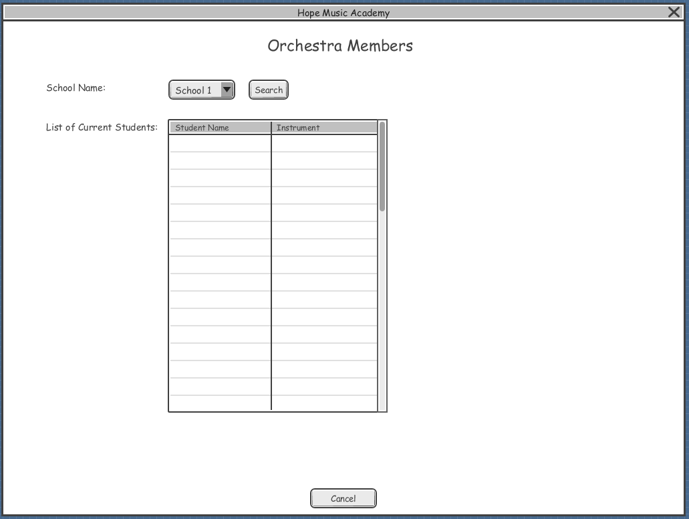

(viii) Bart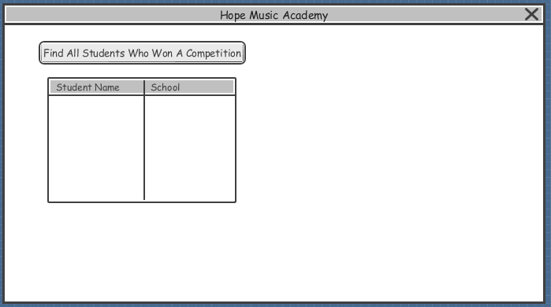

# Sequence Diagrams

(i) Deirdre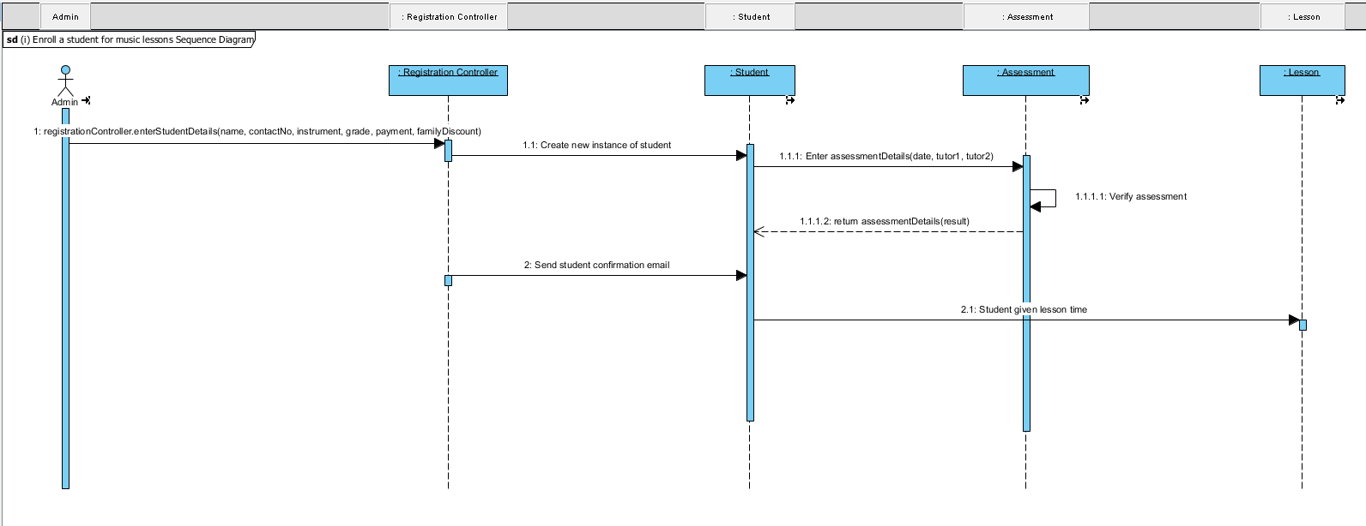

(ii) Bart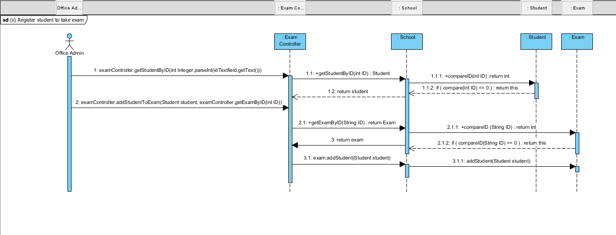

(iii) Deirdre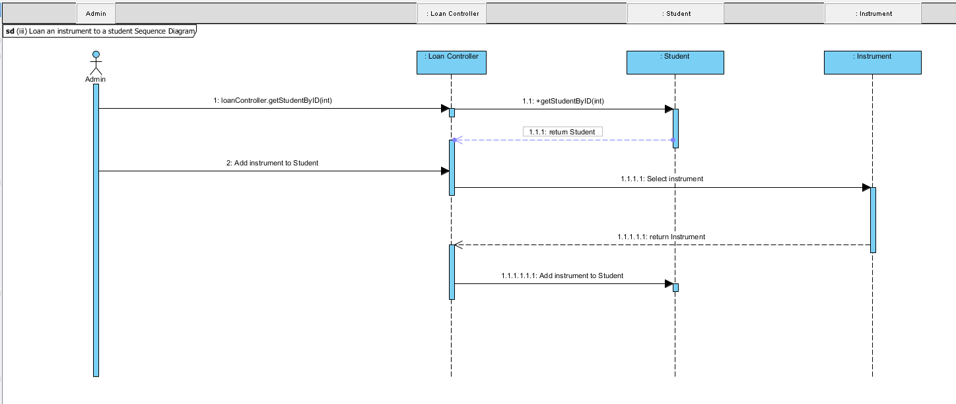

(iv) Bart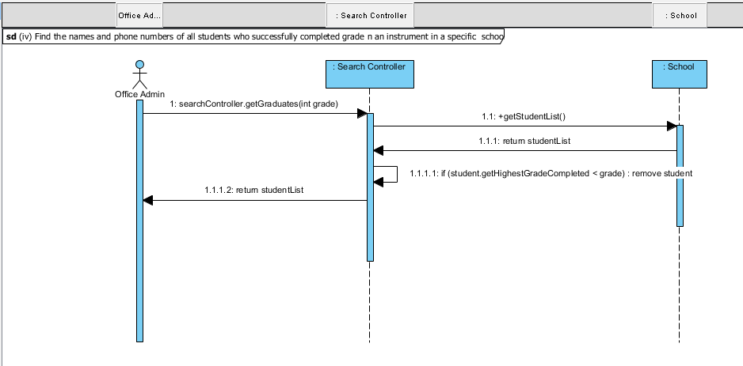

(v) Deirdre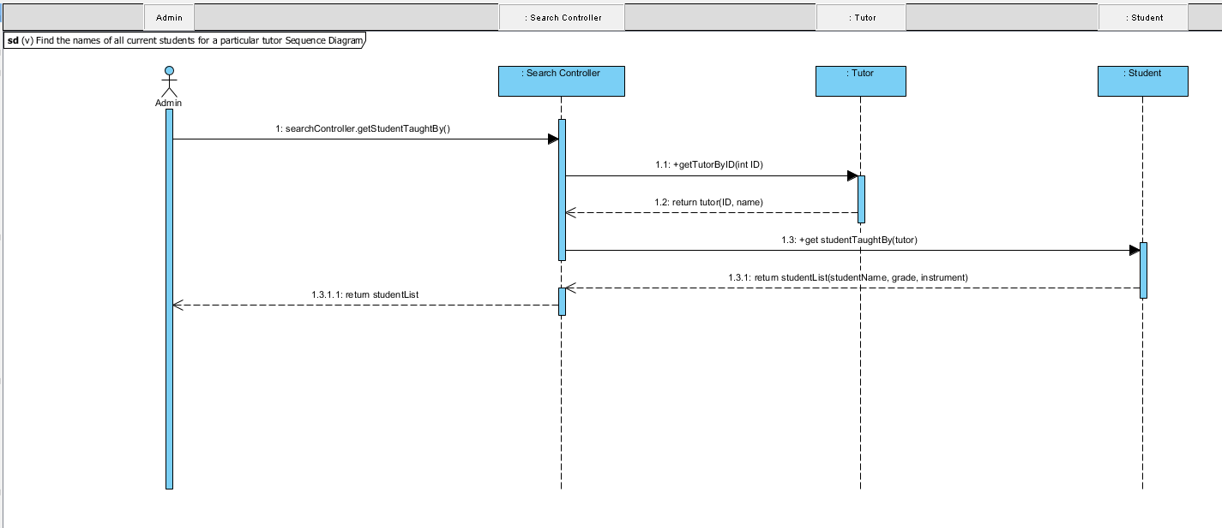

(vi) Bart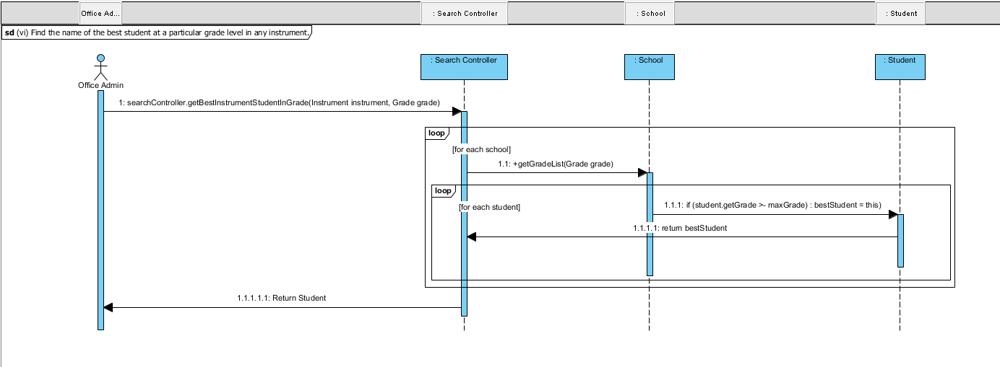

(vii) Deirdre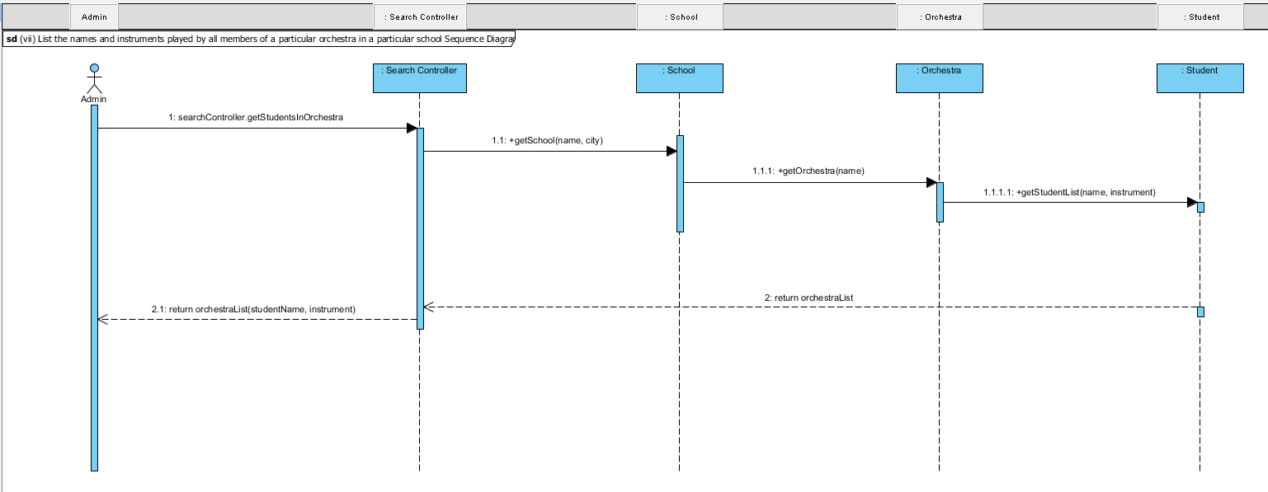

(viii) Bart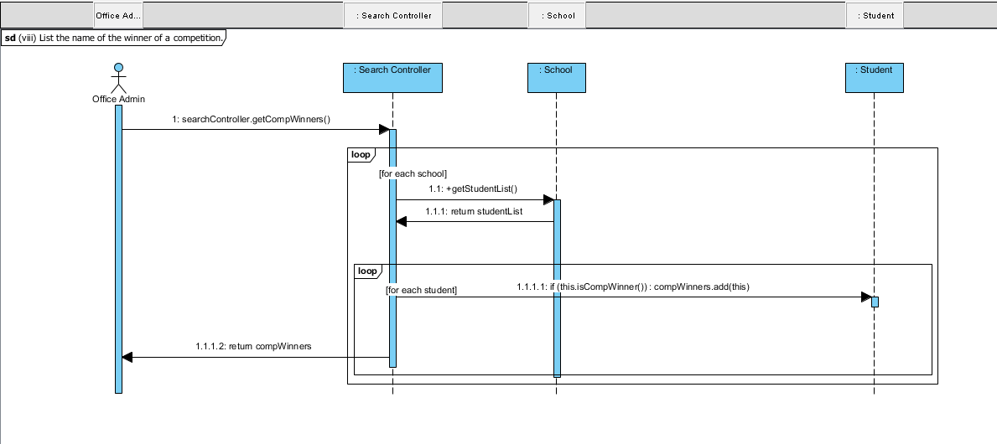

# Design Class Diagram

Deirdre and Bart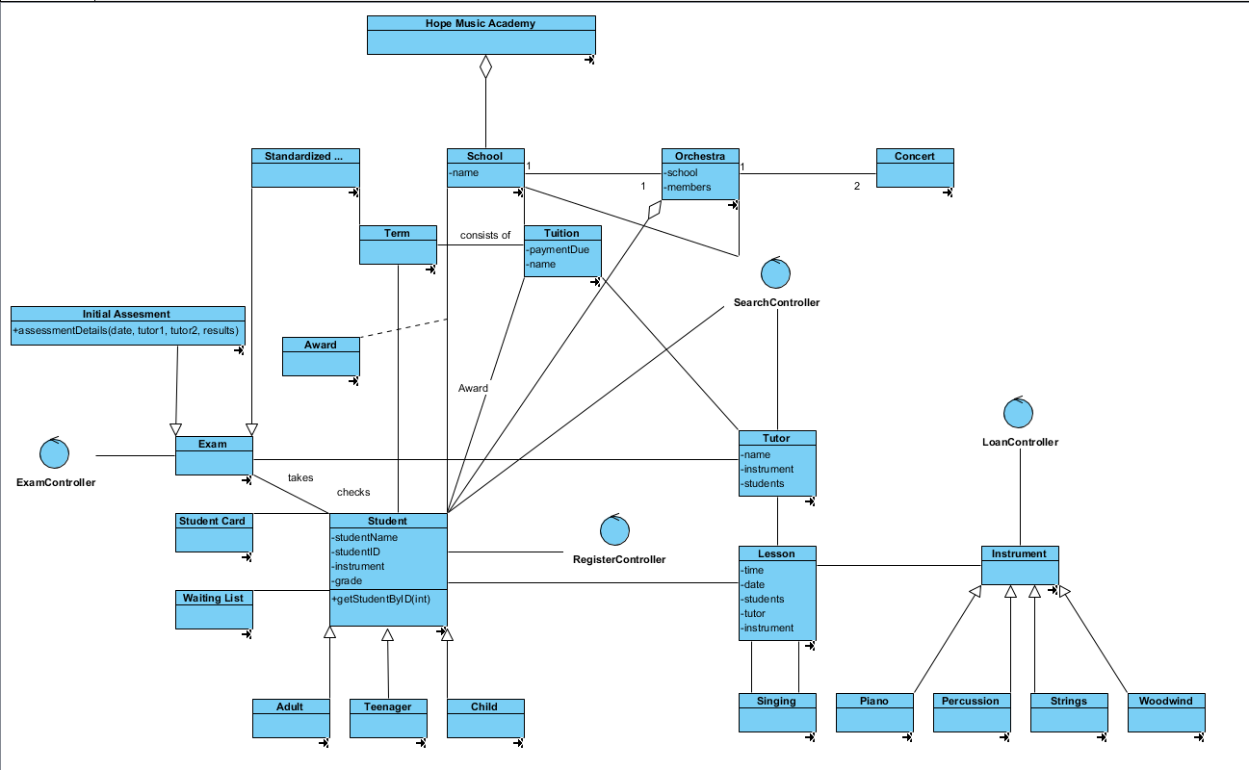

# Design Class Mapping to Java

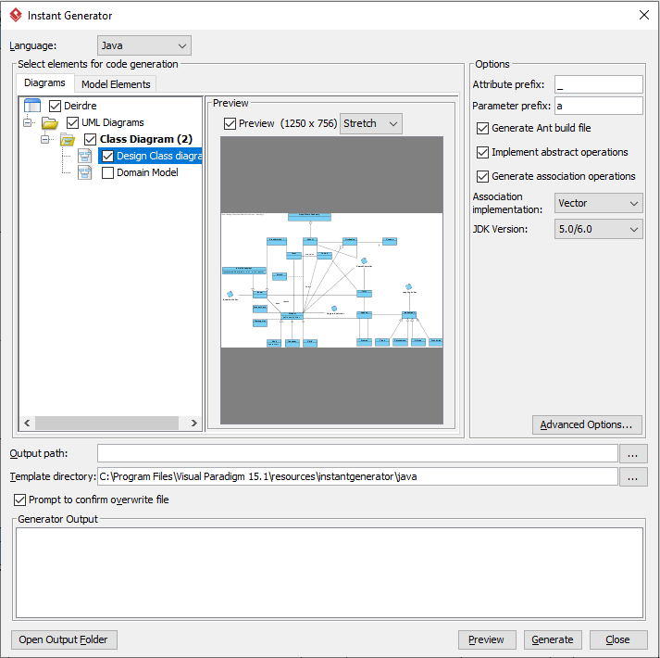

# Design Class Diagram Code

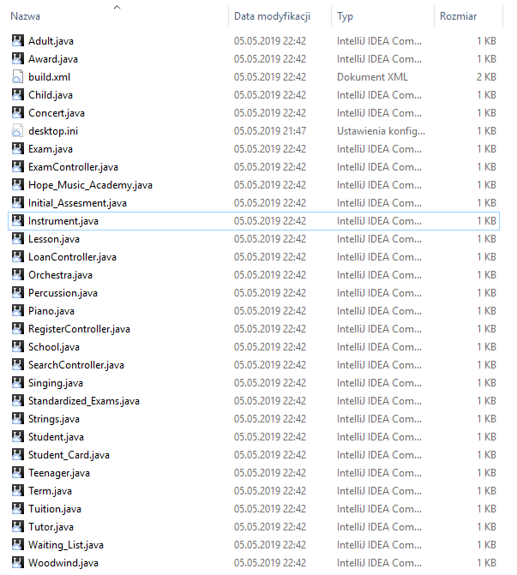

# Student Declaration

I can confirm the following details:

1. Student ID: R00112962

Name: Deirdre Connolly

1. Student ID: R00166560

Name: Bartosz Walusiak

Module Name: OO Analysis and Design

Module Lecturer: Samreen Umer

I confirm that this is my own work.

Due Date: 05/05/19